**13. REACTJS-HQL**

**FOLDER STRUCTURE**

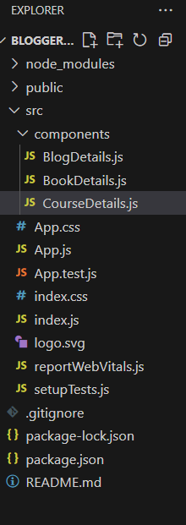

**App.js**

import React, { useState } from 'react';

import BookDetails from './components/BookDetails';

import BlogDetails from './components/BlogDetails';

import CourseDetails from './components/CourseDetails';

function App() {

  const [activeTab, setActiveTab] = useState("books");

  let displayComponent;

  if (activeTab === "books") {

    displayComponent = <BookDetails />;

  } else if (activeTab === "blogs") {

    displayComponent = <BlogDetails />;

  } else {

    displayComponent = <CourseDetails />;

  }

  return (

    <div style={{ padding: '20px', fontFamily: 'Arial' }}>

      <h1>📚 Blogger App</h1>

      <button onClick={() => setActiveTab("books")}>Books</button>

      <button onClick={() => setActiveTab("blogs")}>Blogs</button>

      <button onClick={() => setActiveTab("courses")}>Courses</button>

      <hr />

{displayComponent}

</div>

  );

}

export default App;

**BlogDetails.js**

import React, { useState } from 'react';

import BookDetails from './components/BookDetails';

import BlogDetails from './components/BlogDetails';

import CourseDetails from './components/CourseDetails';

function App() {

  const [activeTab, setActiveTab] = useState("books");

  let displayComponent;

  if (activeTab === "books") {

    displayComponent = <BookDetails />;

  } else if (activeTab === "blogs") {

    displayComponent = <BlogDetails />;

  } else {

    displayComponent = <CourseDetails />;

  }

  return (

    <div style={{ padding: '20px', fontFamily: 'Arial' }}>

      <h1>📚 Blogger App</h1>

      <button onClick={() => setActiveTab("books")}>Books</button>

      <button onClick={() => setActiveTab("blogs")}>Blogs</button>

      <button onClick={() => setActiveTab("courses")}>Courses</button>

      <hr />

{displayComponent}

</div>

  );

}

export default App;

**CourseDetails.js**

import React from 'react';

function CourseDetails() {

  const courses = [

    { id: 1, name: "React Basics", duration: "4 weeks" },

    { id: 2, name: "Advanced JS", duration: "6 weeks" },

  ];

   return (

    <div>

      <h3>📘 Course Details</h3>

      <ul>

        {courses.map(course => (

          <li key={course.id}>

            {course.name} - {course.duration}

          </li>

        ))}

      </ul>

    </div>

  );

}

export default CourseDetails;

**OUTPUT**

